Renju lesson on May 31, 2001

Hello all! Welcome to Online Renju Class.
Today we will study the most popular 14th move. You probably all know where it is.
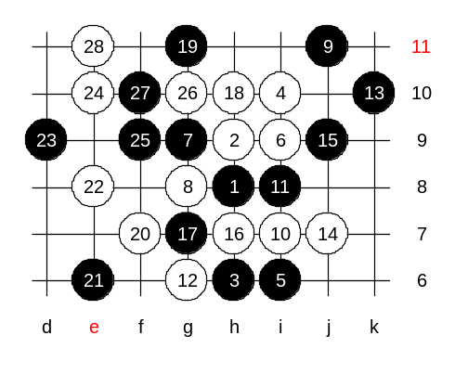
Indeed, j7 is the one. If I remember right, then the move was first played in some Russian games. You ask, why j7. The reason is simple. White had to defend against black VCT, and since the passive defense that we studied before lead to black win, so white will make an attempt to play a little more actively. Now the important connection i6_L9 was closed. Black used i6_L9 connection in most of its attacks before. Suppose black doesn’t play best way, white may easily win as well.
Lets play an example – j9. White can win now. Can you show me the win moves. It seems that white will need f7 point anyway.

So, where is the correct 15th move then?
Move 15-L9 is bad because of 16-i12. Move 15-f7 is too passive. After long analysing, it has become clear that 15-i12 is necessary for winning advantage.
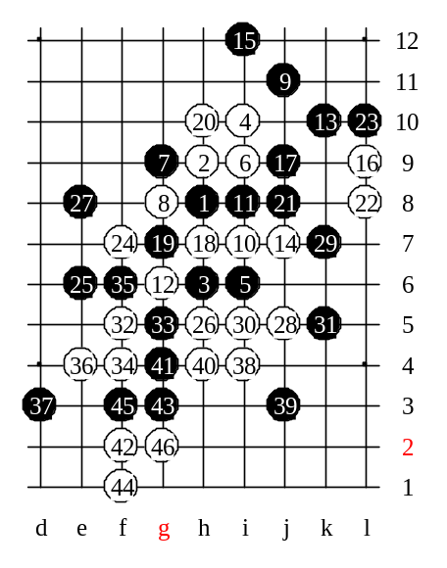
Remember, if black loses the power of i12_L9 line, then black position becomes weak. Move i12 follows the idea of k10. Those are co-operating stones. White has two choices here. Lets study L9 first. Many people think that this variant is easy, but it isn’t. In fact, I have spent lots of time on analyses here, and still have some questions. Move 20-h10 is necessary activity. White must be active in order to avoid instant loss. Now you may think that the position is similar with the previous diagram, but it isn’t. The i12 stone creates the powerful defense line as well as the source for possible counter-attack. After 22-L8 the position is very complicated. Most of you suggested 23-L7 as next move. It is definitely a correct move! It is simple and safe.
But we should be curious, what happens after 23-L10. Because, if L10 is possible, then it is much better for black. Last several days, while preparing for today’s lesson, I deeply analysed L10. I think, it is too early to announce the conclusion of L10. One thing is sure – in case of L10, black either wins, or loses. There will be no balancing.
My recent analyses show that white has a very powerful attack, and so far black has luckily defended. Moves f7 and h7 – preparation. Which side black should block? There is one good way to find out. Lets play and see. We go e8 first.
White wins with 4x4. So we proved that e8 loses.

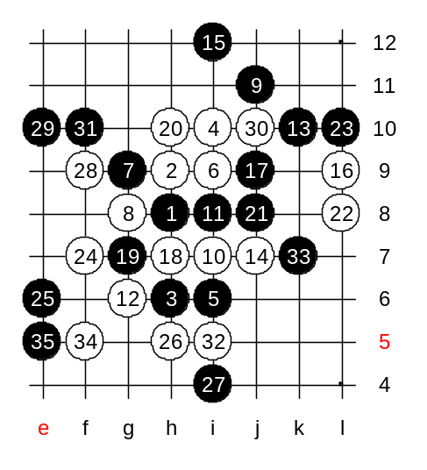
So, we try another block now. White can attack with 28-e10 or 28-f8. But it seems that 28-e10 is not that strong because of 29-f9. (Even 29-f10 seems to be possible in that case, because of black long VCF in one of the long variants).
Therefore we try 28-f9. Now, black has only one possible 29th move. All other moves lose. F10 loses. E10 is the only defense. Black has VCF threat now, do you all see it?
After beautiful 35-e5, white has no win. Black will have just about enough defense power here. As you see, the variant is so difficult, so it is hard to make 100% conclusions about that L10. Agree? Now that white failed the attack, black will win easily soon.

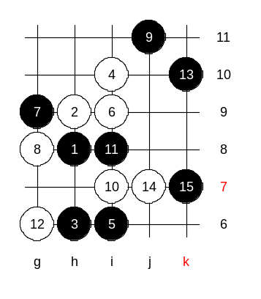

This is the medium level homework. Please find the white win.

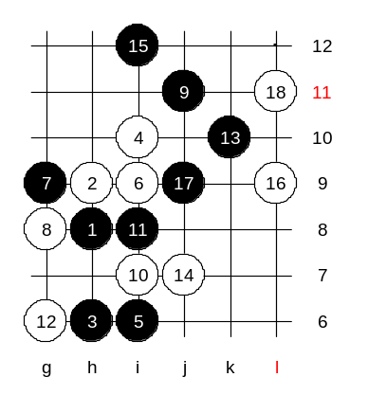

This is the advanced level homework. Please find the black win.

